EXPT NO:2 | LOAD AND VISUALIZE A DATASET USING TABLEAU and PowerBI
DATE: 10.07.2026

PRE-LAB QUESTIONS (PROVIDE BRIEF ANSWERS TO THE FOLLOWING QUESTIONS)

1. Why is Tableau a preferred tool for data visualization?
Tableau is a preferred tool for data visualization because it provides an intuitive drag-and-drop interface that allows users to create interactive and meaningful visualizations with minimal coding. It supports connections to various data sources and offers a wide range of charts, maps, and dashboards. Tableau enables users to analyze large datasets efficiently, identify trends and patterns, and present insights through visually appealing and interactive reports that support better business decision-making.

2. What is the primary use of a line chart in data analysis?
A line chart is primarily used to visualize changes or trends in data over a period of time. It is especially useful for analyzing continuous data such as sales, stock prices, revenue, or monthly performance. By connecting data points with lines, it helps users identify increasing or decreasing trends, seasonal variations, and fluctuations. Line charts are widely used in business intelligence and financial analysis to compare performance and monitor changes over time effectively.

3. When would you use a tree map instead of a bar chart?
A tree map is used when displaying hierarchical data or showing the proportion of categories within a whole. It represents values using nested rectangles, where larger rectangles indicate higher values. Compared to a bar chart, a tree map is more suitable when there are many categories and limited display space. It allows users to compare the contribution of categories and sub-categories simultaneously while making efficient use of the available dashboard area.

4. What is the significance of filters in Tableau visualizations?
Filters in Tableau are important because they allow users to display only the data that meets specific conditions, making analysis more focused and interactive. Users can filter data by attributes such as date, region, category, or customer segment to explore different perspectives without modifying the original dataset. Filters improve dashboard usability, simplify data exploration, and help users identify meaningful insights by concentrating only on the most relevant information.

5. How does Tableau handle geographic data for visualizations?
Tableau has built-in geographic capabilities that automatically recognize fields such as country, state, city, and postal code. It assigns appropriate geographic roles and generates maps without requiring additional configuration. Users can visualize measures like sales or profit using color gradients, symbols, or varying marker sizes on maps. This enables effective geographic analysis, helping organizations compare regional performance, identify location-based trends, and make informed business decisions based on spatial data.

IN-LAB EXERCISE:
OBJECTIVE:
To load a dataset into Tableau, create a variety of visualizations, and derive insights from the data using different chart types available in Tableau.

PROCEDURE:

Dataset Selection:
Use the Global Superstore Sales Dataset (available on Kaggle or Tableau's sample datasets).
Ensure the dataset includes fields like Order Date, Category, Region, Sales, Profit, and Customer Segment.

Data Loading:
Open Tableau and connect to the dataset.
Review the dataset structure, field data types, and missing values.
Chart Creations (Step-by-Step):
- Bar Chart:
Objective: Compare total sales by region and category.
Plot Region on the x-axis and Sales on the y-axis. Add Category as a color dimension.
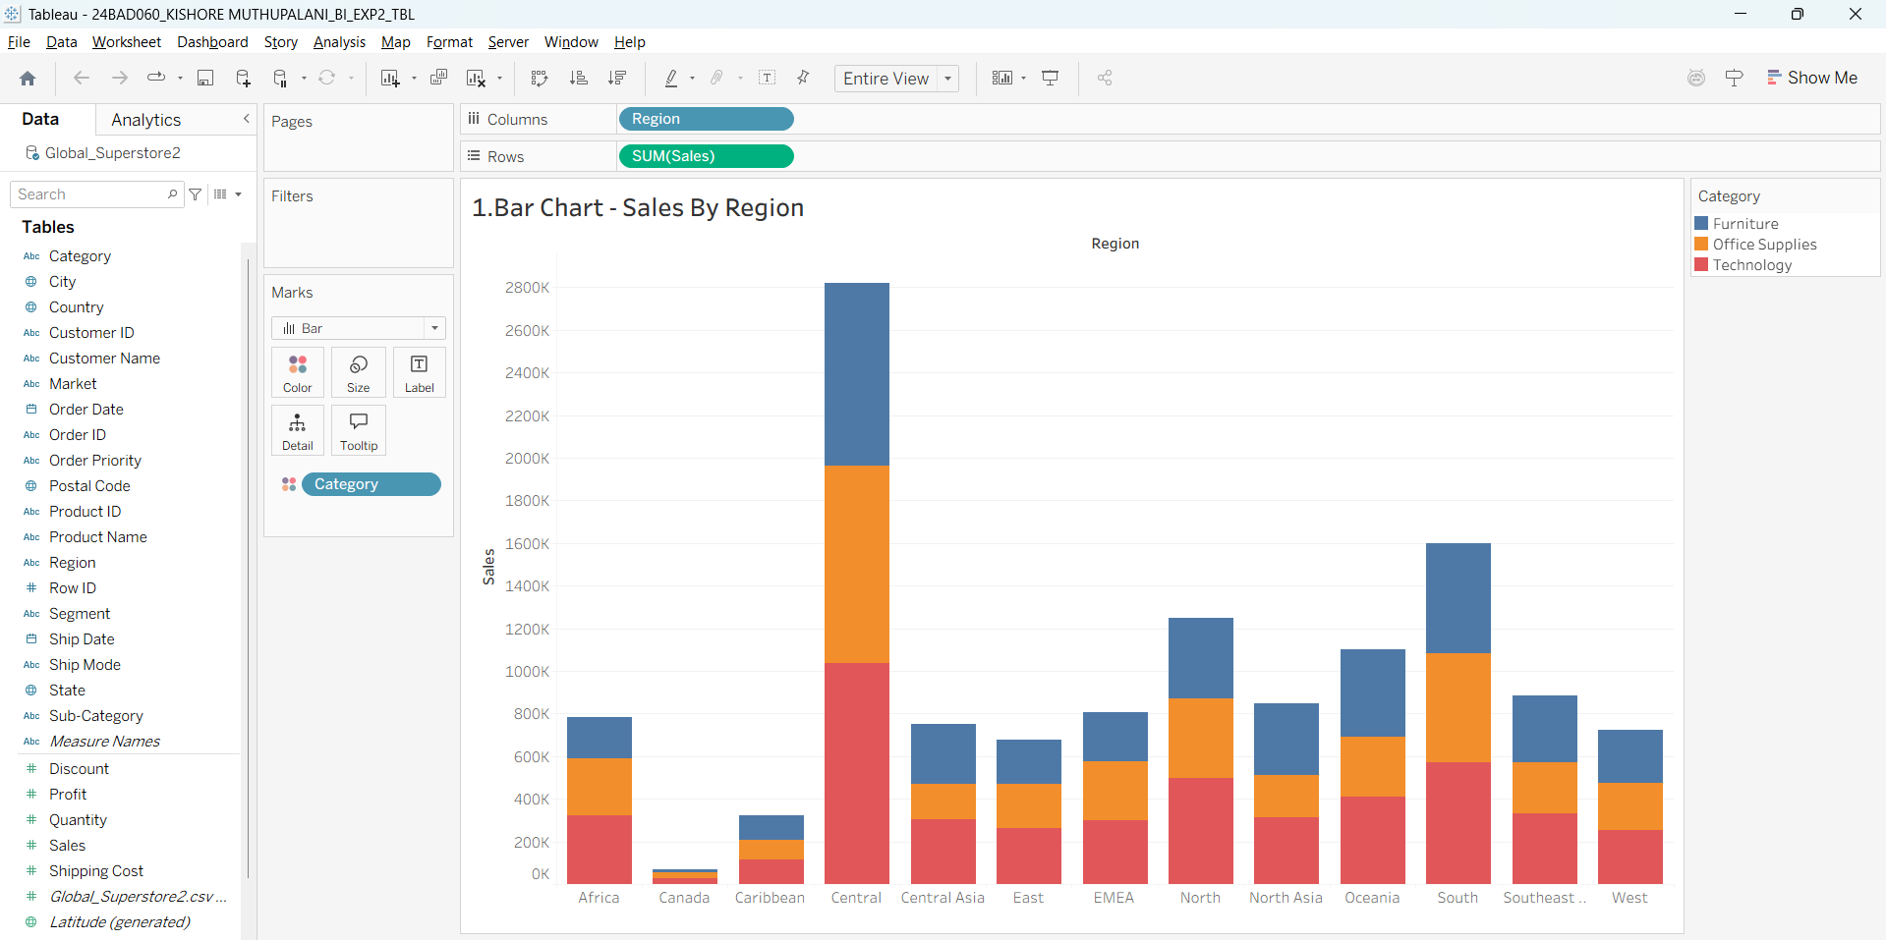

Line Chart:
Objective: Visualize sales trends over time.
Place Order Date on the x-axis and Sales on the y-axis. Set granularity to Month and color by Category.
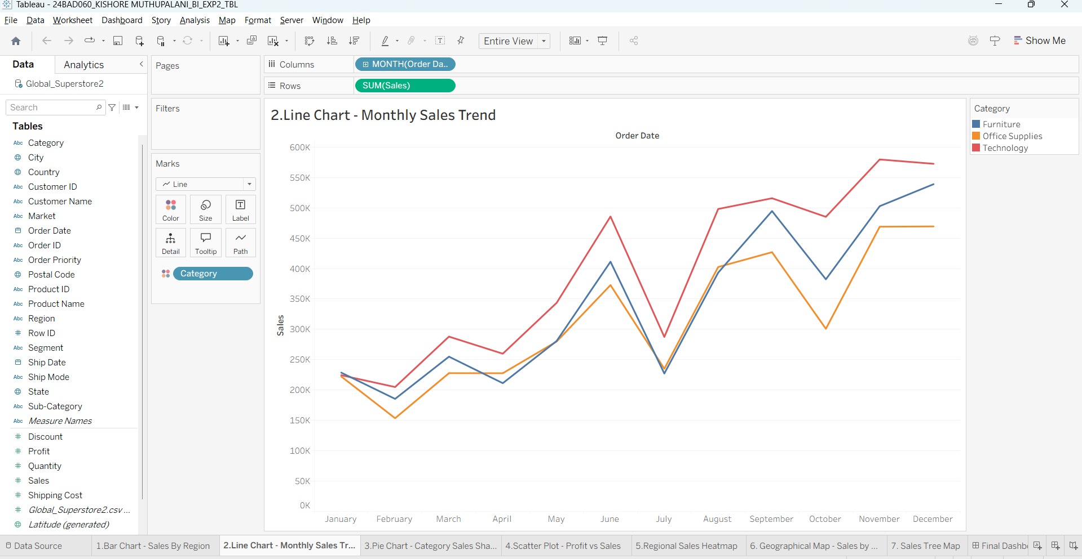

Pie Chart:
Objective: Show sales distribution by product category.
Assign Category as the dimension and Sales as the measure.
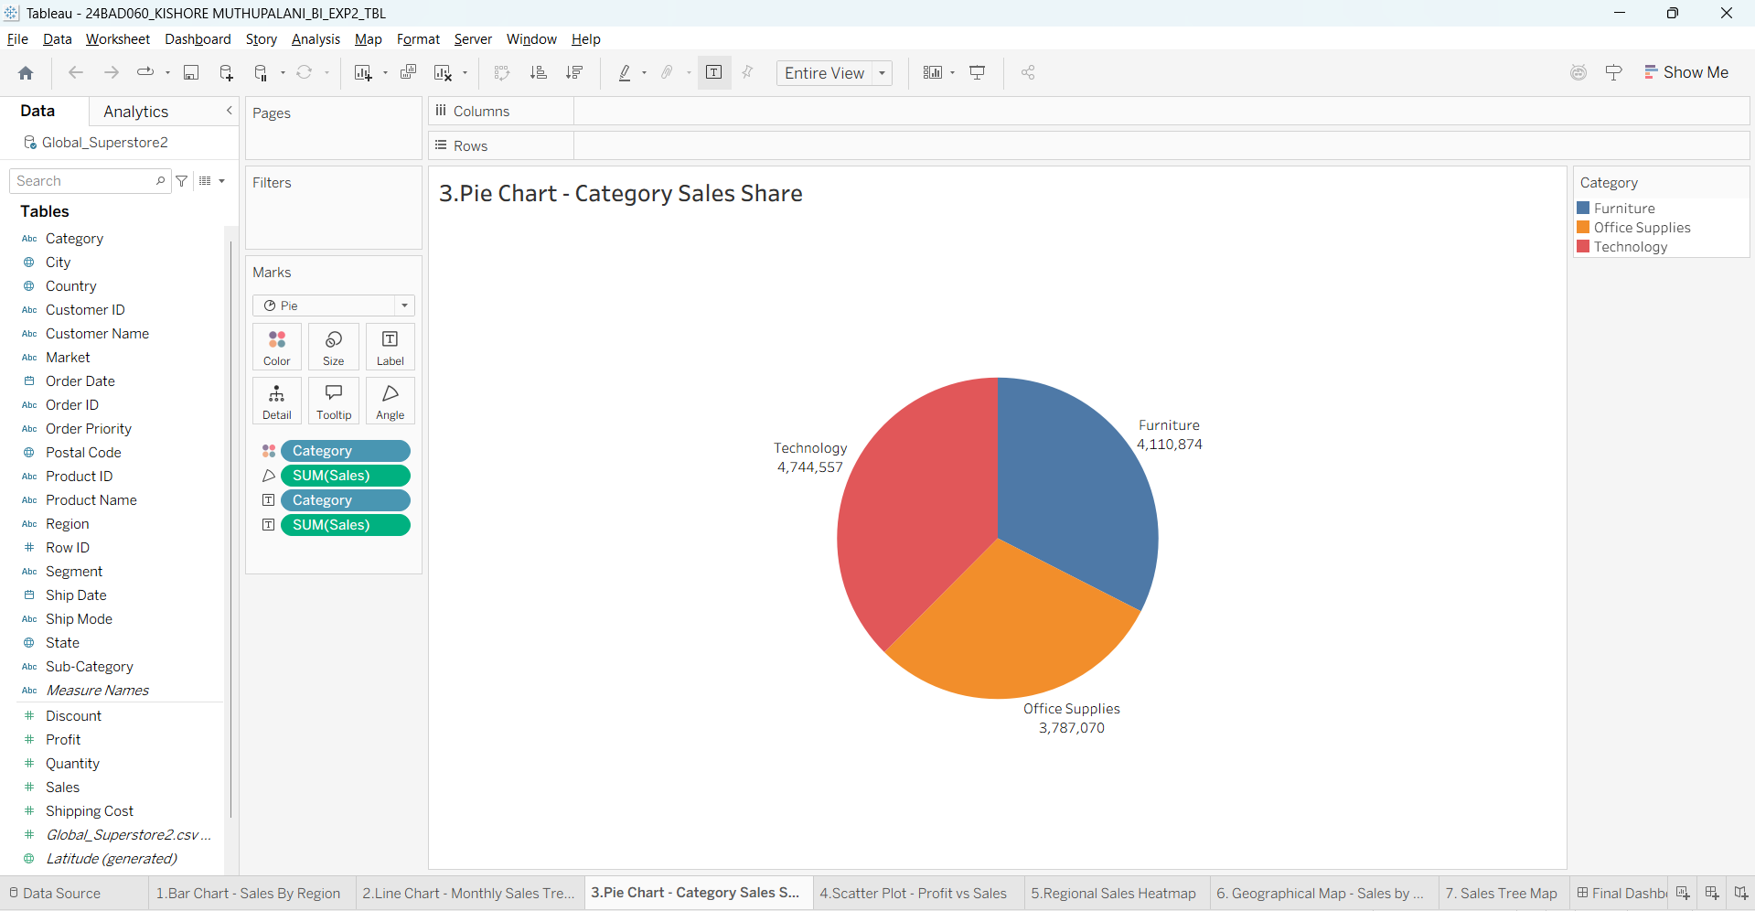

Scatter Plot:
Objective: Examine the relationship between profit and sales.
Plot Profit on the x-axis and Sales on the y-axis.

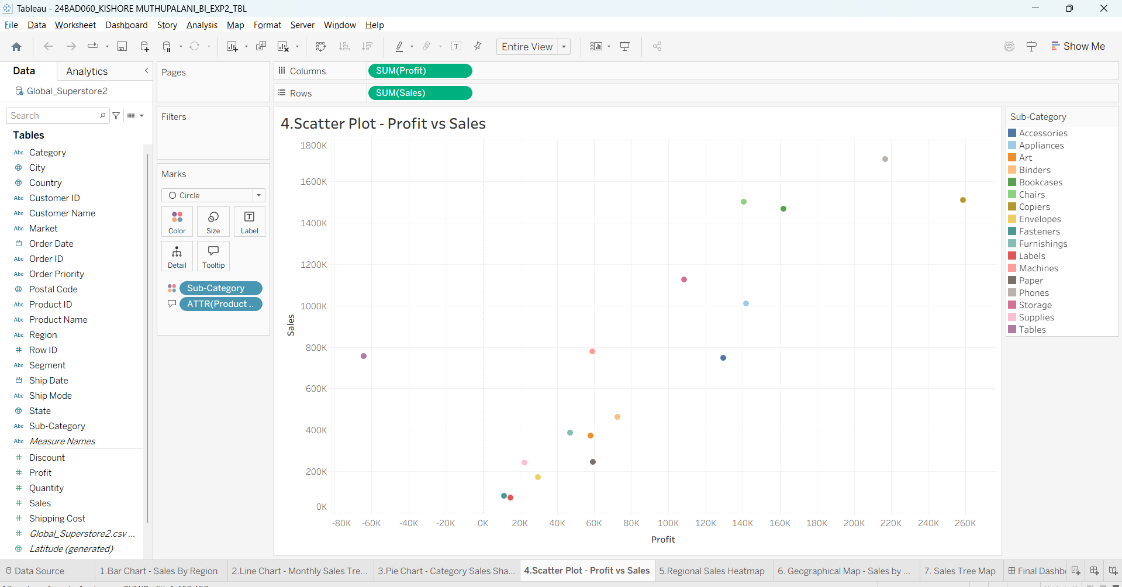
Use Sub-Category as the color dimension.

Heatmap:
Objective: Compare sales across categories and regions.
Use Region and Category as dimensions.
Use Sales as the measure and apply color coding.
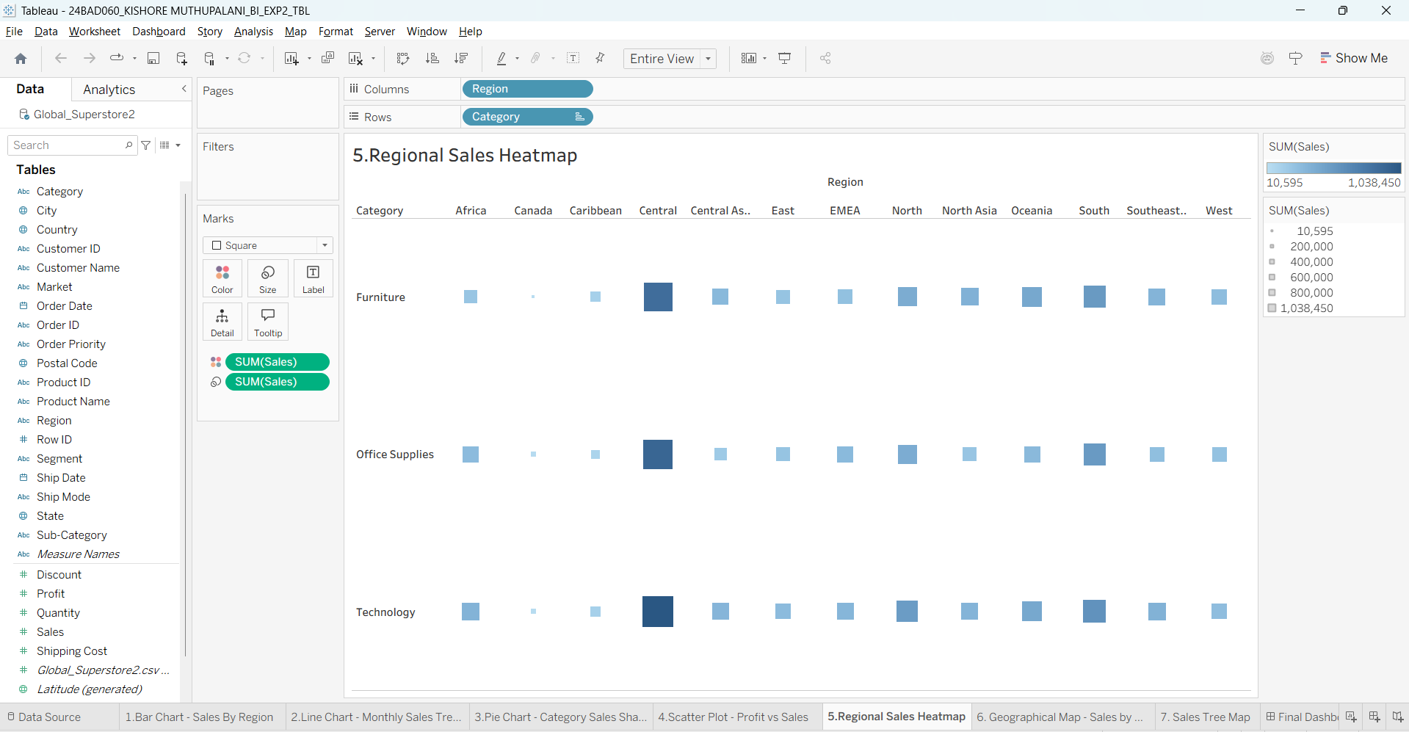

Geographical Map:
Objective: Visualize total sales by country.
Set Country as the geographical field.
Use Sales to define size and color gradients.
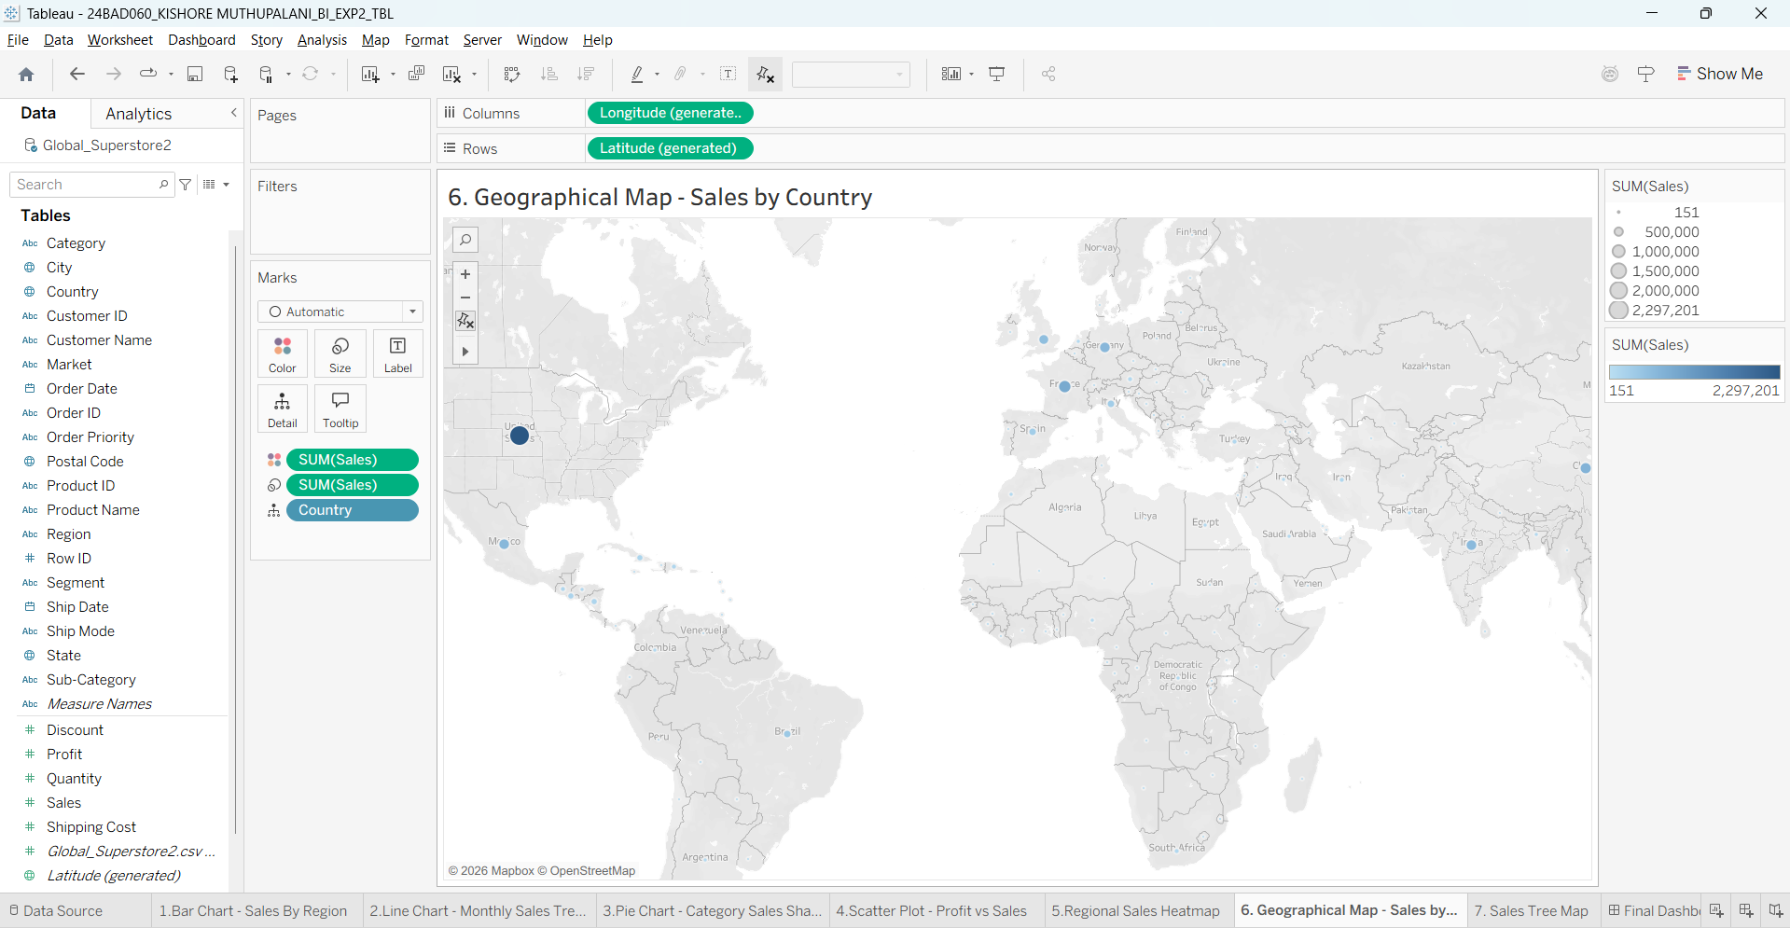

Tree Map:
Objective: Display sales distribution by category and sub-category. Use Category and Sub-Category as dimensions, and Sales as the measure.
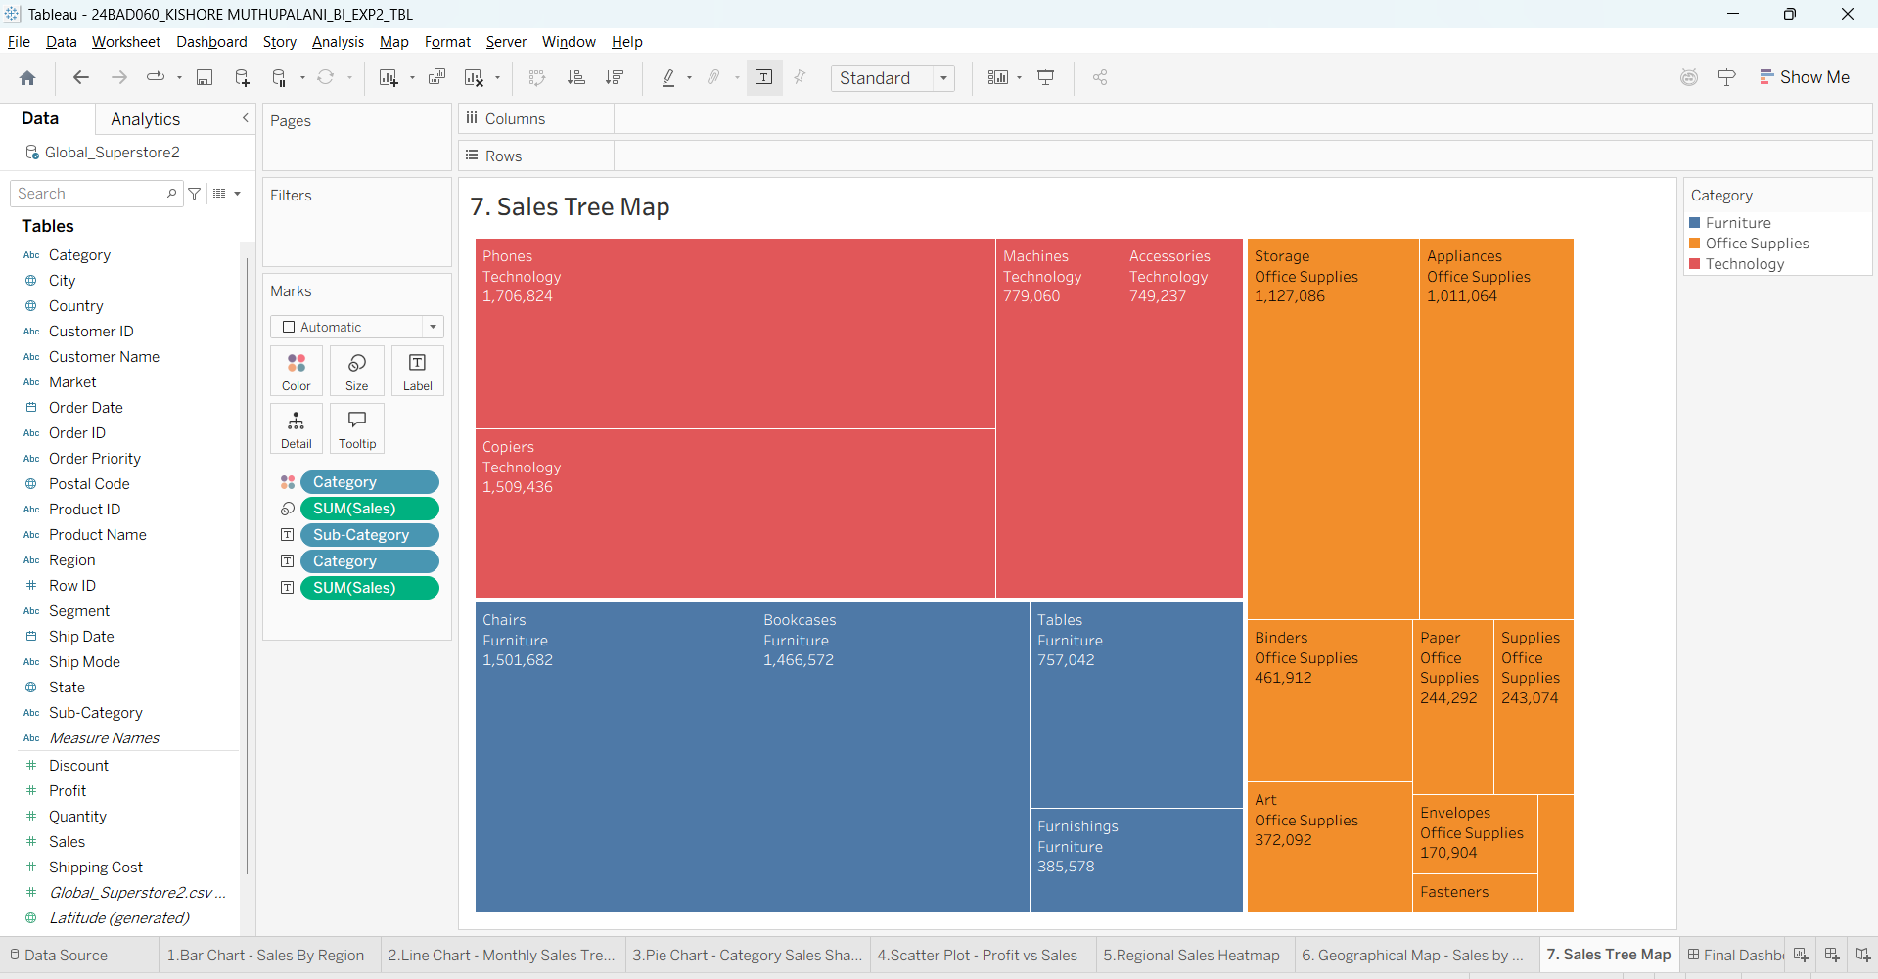
Customization and Interactivity:
Add filters to explore data subsets interactively (e.g., by year, region, or category). Include annotations, labels, and formatting for clarity.

Dashboard Creation:
Combine all charts into a single dashboard to present a cohesive story. Add interactive filters and tooltips for dynamic exploration.
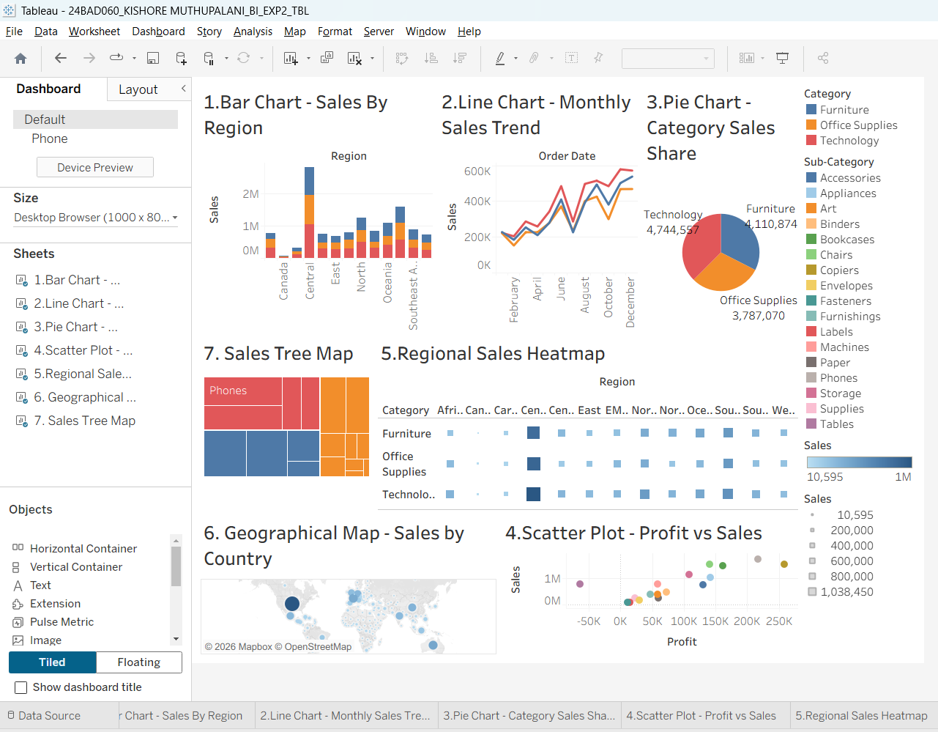

Experiment Dataset:
Global Superstore Sales Dataset
Source: https://www.kaggle.com/datasets/apoorvaappz/global-super-store-dataset

Fields Used:
Order Date Region Category
Sub-Category Sales
Profit
Country

POST-LAB QUESTIONS (PROVIDE BRIEF ANSWERS TO THE FOLLOWING QUESTIONS)

1. Bar Chart: What regions had the highest and lowest total sales? How does the performance of categories vary across regions?
The Central region recorded the highest total sales with approximately 2.82 million, while Canada had the lowest sales with about 66.9 thousand. Across almost all regions, the Technology category generated the highest sales, followed by Furniture and Office Supplies. The Central and South regions performed consistently well across all categories, whereas Canada and the Caribbean showed comparatively lower sales, indicating differences in regional market demand and business performance.

2. Line Chart: Identify the month with peak sales. Which category shows consistent growth in sales over time?
The line chart shows that November 2014 recorded the highest monthly sales, reaching approximately 555,279. This indicates a strong increase in sales during the year-end period. Among the three categories, Technology demonstrated the most consistent growth over time, maintaining higher monthly sales than Furniture and Office Supplies. Although all categories experienced periodic fluctuations, Technology showed a steady upward trend, making it the strongest performing category throughout the observed period.

3. Pie Chart: Which category contributes the most to overall sales? Are there any categories with negligible sales contributions?
The pie chart reveals that Technology contributes the largest share of total sales, generating approximately 4.74 million. It is followed by Furniture with about 4.11 million and Office Supplies with around 3.79 million in sales. None of the three categories have a negligible contribution, as each represents a significant portion of the overall revenue. The visualization highlights a balanced distribution while emphasizing Technology as the leading contributor.

4. Scatter Plot: Is there a noticeable correlation between profit and sales? Which sub-category shows the highest sales but low profit?
The scatter plot indicates a generally positive relationship between sales and profit, where higher sales often result in higher profits. However, some sub-categories deviate from this trend. Tables stand out as having relatively high sales (approximately 757,042) but a negative total profit (around –64,083). This suggests that despite generating strong revenue, the Tables sub-category incurred losses, possibly due to heavy discounts, high production costs, or lower profit margins.

5. Heatmap: Which region-category combination has the highest sales? Identify any regions with poor sales performance across all categories.
The heatmap shows that the Central–Technology combination achieved the highest sales, with approximately 1.04 million, followed by Central–Office Supplies and Central–Furniture. On the other hand, Canada consistently displayed the lowest sales across all three categories, with Furniture performing particularly poorly. The Caribbean region also recorded comparatively lower sales than most other regions. The heatmap effectively highlights strong and weak regional performances using color intensity.

6. Geographical Map: Which country has the highest total sales? Are there regions with minimal or no sales?
The geographical map indicates that the United States recorded the highest total sales, generating approximately 2.30 million. Other strong-performing countries include Australia, France, China, and Germany. Although every country in the dataset reported some sales, a few countries such as Equatorial Guinea, Armenia, Eritrea, and Macedonia had very low sales, making them appear as regions with minimal business activity on the map.

7. Tree Map: Which sub-category dominates the sales in each category? Are there any sub-categories with unexpectedly low sales?
The tree map shows that Chairs dominate the Furniture category, Storage leads Office Supplies, and Phones generate the highest sales within Technology. These sub-categories occupy the largest areas in the visualization due to their significant contribution to total sales. In contrast, Labels and Fasteners in Office Supplies recorded comparatively low sales, making them the smallest sections of the tree map and indicating relatively lower customer demand.

8. Dashboard: What insights can you derive when combining all visualizations? How do filters enhance the utility of the dashboard?
The dashboard provides a comprehensive view of sales performance by combining multiple visualizations, enabling comparisons across regions, categories, countries, and time periods. It highlights that Technology is the leading category, the Central region generates the highest sales, and the United States is the top-performing country. Interactive filters for Year, Region, and Category allow users to analyze specific subsets of data, making the dashboard more dynamic, user-friendly, and effective for business decision-making.

ASSESSMENT

Description | Max Marks | Marks Awarded
Pre Lab Exercise | 5
In Lab Exercise | 10
Post Lab Exercise | 5
Viva | 10
Total | 30
Faculty Signature

